Full CRUD Operation Using .Net 6.0-User Manual
List CRUD is ASP.NET Core (6.0), C#, EF code first web applications which help you to create, update delete and read operation very smoothly with cool UI and firster paging, sorting, and searching functionality.
Technologies:
Microsoft Visual Studio Community 2022/Later, ASP.NET Core 6.0, Entity Framework Code First, MSSQL SERVER 2017/MySQL, JavaScript, JQuery data table, bootstrap 4, sweetalert, toastr,Fontawesome etc.
Prerequisite Application:
Microsoft Visual Studio Community 2022/Later, Dot Net Core 6.0, MS SQL SERVER 2017/MySQL, IIS, Chrome/Edge Browser.

How to run this Project:
Step 1:
Unzip the downloaded folder (ListCRUD_src.zip)
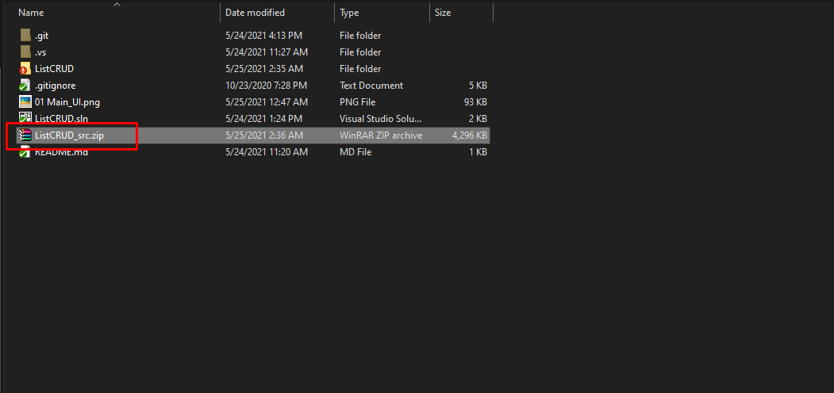

Step 2:
Open ListCRUD.sln file with Visual Studio 2022
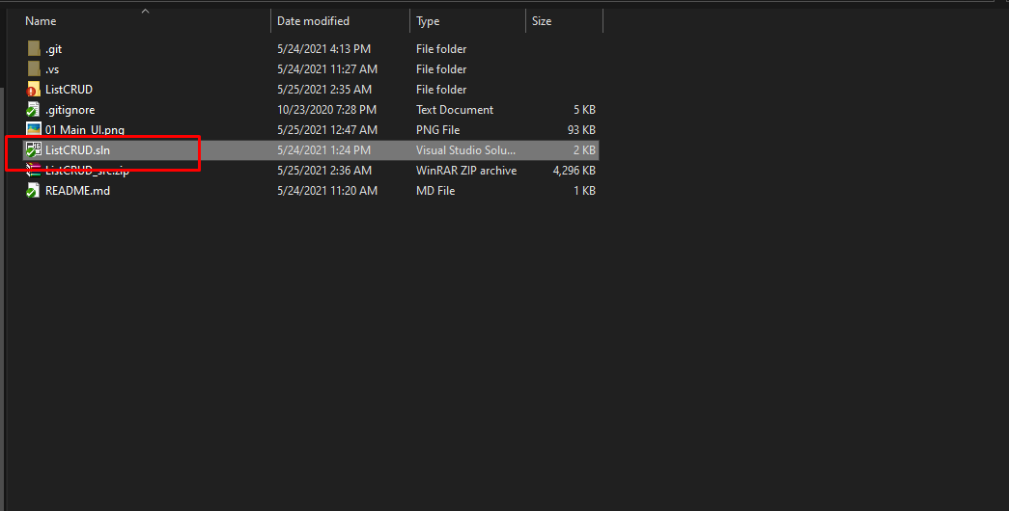
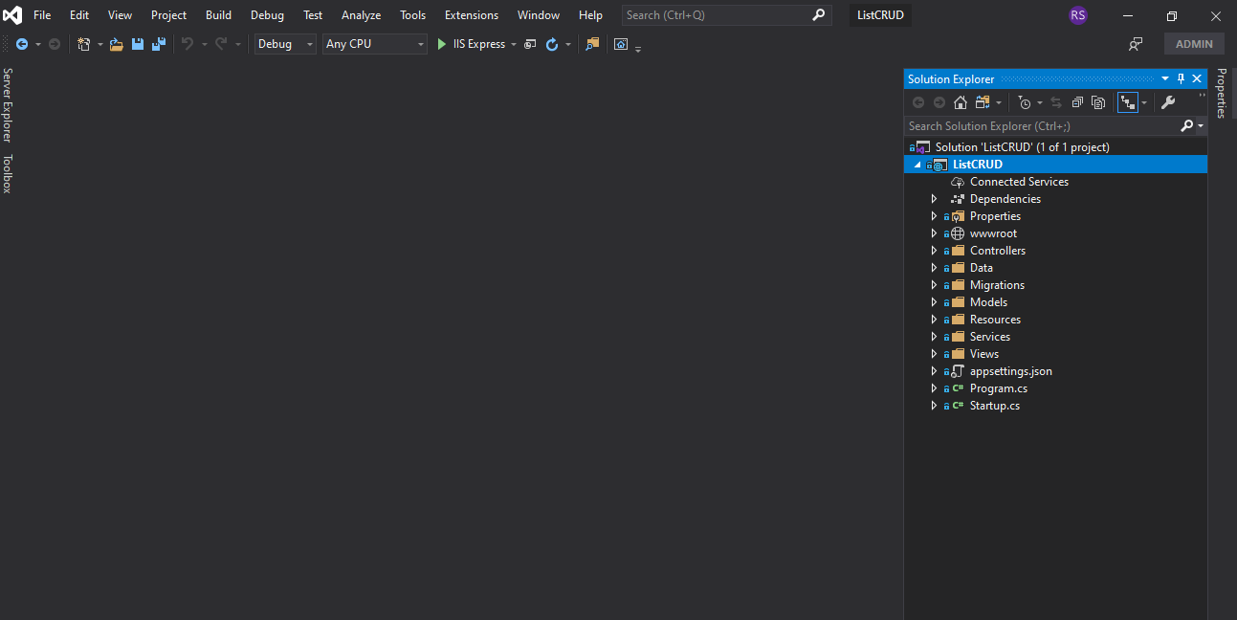

Step 3:
Update database connection: appsettings.json
“DefaultConnection”: “Server=DEVSTATION\\MSSQLSERVER2017;Database=ListCRUDDev User ID=sa;Password=dev123456”
Server=Your MS SQL Server Name
User ID= Your MS SQL Server User Name
Password= Your MS SQL Server User Password
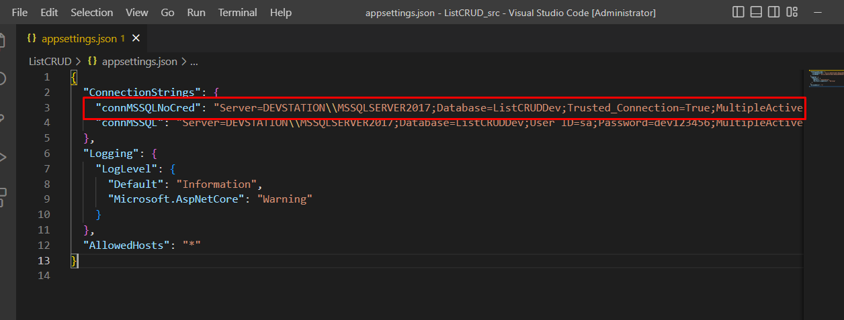
Step 4:
No need to create migration rule and update database. You just need to build and run the application. Already initial migration rule included with project. Please make sure MS SQL server running properly.
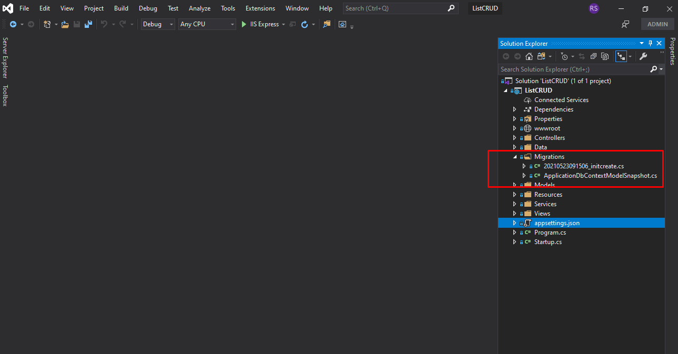
Step 5:
5.1: Build application by pressing f6
5.2: Run application by pressing f5
https://localhost:44373/
Initially in SQL server, 1k plus demo data will be created in the database dynamically as code first approach.

Step 6:
Browse full application.
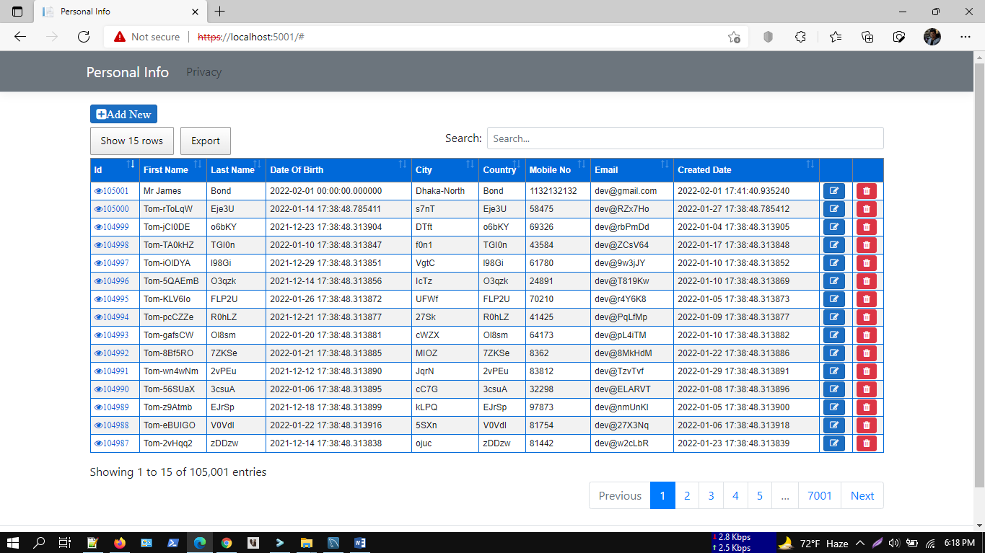
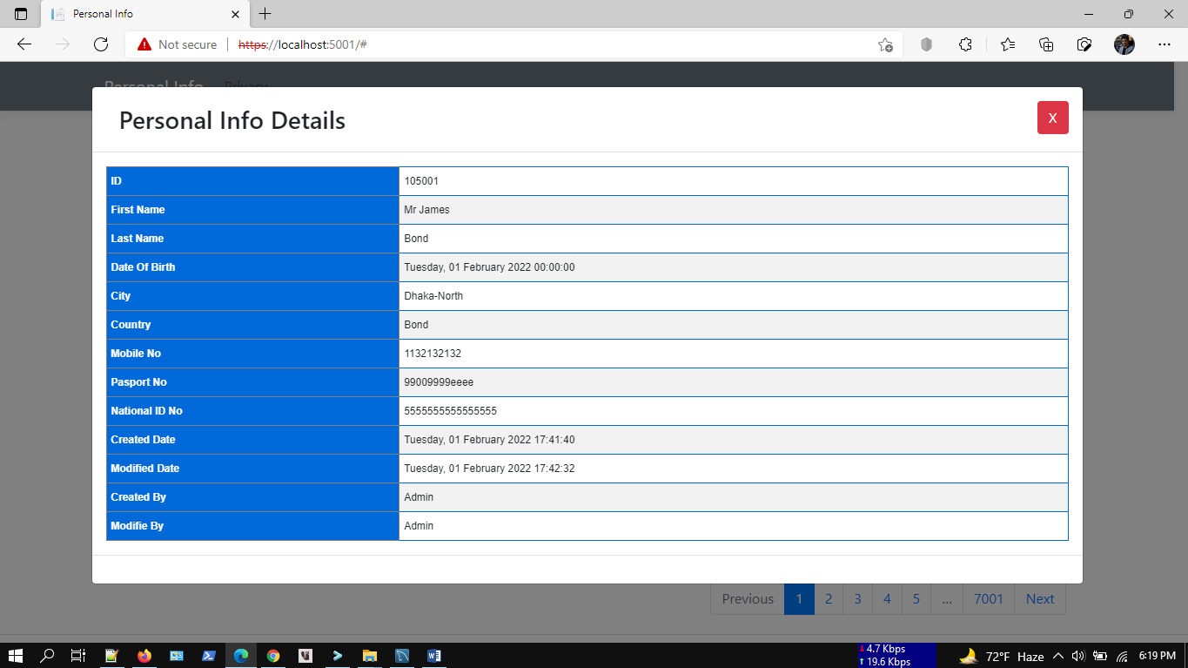

Demo Video Preview
https://youtu.be/GvDOEg0buXs

Key Features:
+ Full CRUD without full page load.
+ MSSQL/MySQL
+ .NET 6.0
+ EF Code first
+ Faster data load with 100k plus demo data loading
+ Faster searching
+ Faster pagination
+ sweetalert
+ Bootstrap Modal
+ Data export
+ Column ordering
DB Migration:
Tools--> Nuget Package Manager--> Package Manager Console

PM> add-migration initcreate
PM> update-database

Check .Net Version:
Press Windows + R.
Type cmd.
On the command prompt, type dotnet --version

Run Project From Terminal/PowerShell:
1. > E:\gitClone\ListCRUDDotNet6\ListCRUD
2. > dotnet build
3. > dotnet run

Supports:
If you want to modify or add new features, or any technical issue you can always contact us at,
WhatsApp: 8801674411603
Telegram: shahed71bd
Skype: shahedatomap
shahedbddev@gmail.com

